**2045 Tri-County Transportation Plan**

**MetroQuest Survey Results Appendix A – Survey Comments**

****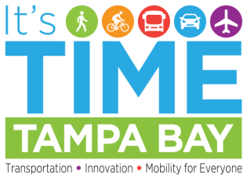

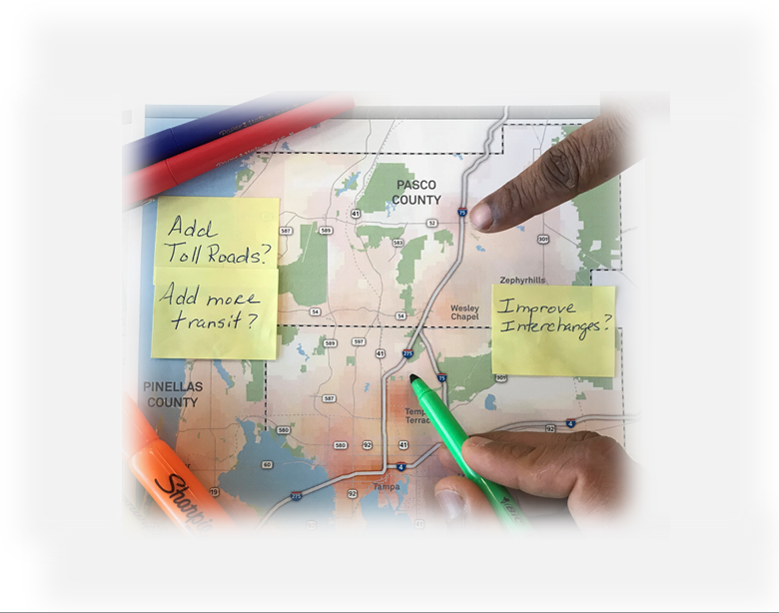

**December 2018**

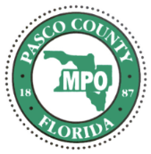***Prepared for***

***Prepared by***



|  |
| --- |
| **Introduction** |

The MetroQuest survey provided commentators the opportunity to comment on priorities (screen 2), exaggerated scenarios (screen 3), and the individual planning elements (screen 4). In total, there were 9,944 comments provided. A breakdown of the comments by screen is as follows:

* **Priorities** – 767 comments
* **Scenarios** – 3,114 comments
* **Elements** – 6,063 comments

The following sections summarize the general themes of the comments received.

|  |
| --- |
| **Priorities** |

Survey respondents were asked to identify their top five priorities. Traffic Jams and Alternatives to Driving led the tier one comments, identified by approximately 75% of commentators. Preserving Open/Green Space and Shorter Commutes were tier two comments, identified by approximately 62% to 64% of commentators. Storm Vulnerability (approximately 50%), Public Service Costs (approximately 50%), and Equal Opportunity (approximately 40%) rounded out the priorities. The following sections provide a brief overview of the comments associated with each of the priorities.

**Traffic Jams**

Survey commentators provided 160 comments related to traffic jams. Overall, commentators expressed their concerns regarding the high levels of traffic congestion throughout the tri-county area. The I-4 corridor in general, and the I-4 and I-275 interchange specifically, were identified as locations with excessive traffic jams. There was also an overall recognition among survey commentators that the outward growth occurring in the region is a major contributing factor in the traffic situation getting worse each year. Some commentators suggested the need to stop building/widening roads and to focus on alternative travel modes such as public transportation. Other commentators mentioned the need to look at improvements such as better traffic signal timings to help existing traffic move more efficiently.

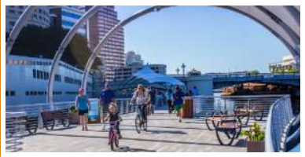**Alternatives to Driving**

Survey commentators provided 244 comments related to Alternatives to Driving. A number of modes were identified as alternatives to driving. In general, transit improvements were mentioned as a positive alternative to driving. Most notably, rail transit was highly supported and recommended among many commentators. Light rail in Downtown Tampa with connections over Tampa Bay bridges were commonly suggested as an alternative to congested roadways and a good way to connect the tri-county area. Commentators were somewhat critical of bus transit unless routes had designated right of way and could move freely without interference from vehicular congestion. This comment in particular supports the high response to traffic jams—commentators not only want alternatives to driving but they want alternatives that provide faster, more reliable trips. Bicycle and pedestrian connections were also supported as viable transportation options. Bike lanes were mentioned frequently as an alternative to driving with commentators indicating the need to concentrate on bike infrastructure improvements that enhance safety for bicyclists by reducing potential conflicts with vehicular traffic. To a somewhat lesser degree, these comments also apply to providing safe sidewalk connections to enhance walking within neighborhoods.

**Shorter Commutes**

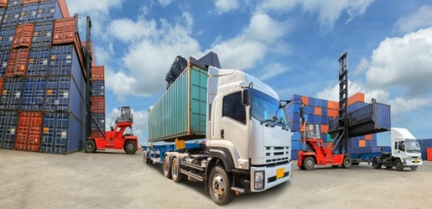Survey commentators provided 84 comments related to Shorter Commutes. Many commentators reinforced their dismay at the amount of congestion in the Tampa region and their belief that reducing commute times would be a major benefit for area residents. Some commentators suggested that they would like to have more options to live closer to where they work—ultimately decreasing their commute time. Other survey comments focused on infrastructure-based solutions. Some commentators suggested building a passenger rail system, improving roadway flow by using smarter traffic signals, and implementing car-carrying water ferries across the bay to remove cars from area bridges as possible solutions to help shorten commutes.

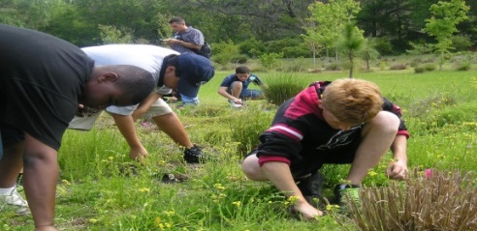**Open Space**

Survey commentators provided 104 comments related to preserving Open Space. Commentators in particular referenced the importance of protecting wetlands within the tri-county area. Regardless of the type of natural space, protection of the area’s wildlife was another priority among commentators. Survey commentators also mentioned the importance of providing access to residents and visitors that will allow for the enjoyment of natural environments without negatively impacting green space and wildlife. Smart development was frequently identified as a key component to ensure wetlands and wildlife inhabitants are protected. Striking a balance between the natural environments and built environments must be taken into account within land use and development plans.

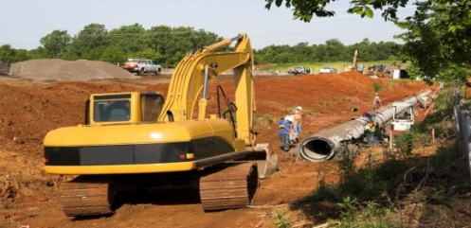**Public Service Costs**

Survey commentators provided 31 comments related to Public Service Costs. Survey commentators expressed their concern regarding increasing public service costs and better management of current funding without raising taxes. Introducing the idea of private investment to fund infrastructure costs was identified as an option to help creatively save taxpayer money. Additional comments referenced the need to upgrade sewers, invest in transportation infrastructure, and promote smart development and planning to limit or reduce the burden on public service infrastructure.

**Equal Opportunity**

Survey commentators provided 68 comments related to Equal Opportunity. Commentators acknowledged equal opportunity as a critically important component and mentioned a number of groups that must be given equal consideration. Survey commentators highlighted the need to better connect affordable housing and transit to ensure residents have access to jobs. Low-income, disability, and minority groups were mentioned as individuals and communities that could benefit from transportation initiatives focused on equally distributing funding resources.

**Storm Vulnerability**

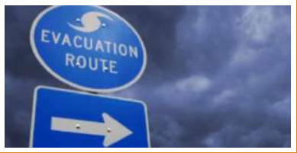Survey commentators provided 76 comments related to Storm Vulnerability. Survey comments on storm vulnerability came in particular from Pinellas County residents. A major concern among commentators was the threat of flooding from storms such as hurricanes or rising sea levels. Avoiding development in vulnerable areas and providing emergency action plans and policies for those located in areas susceptible to flooding were mentioned by many commentators. Improving evacuation routes with alternatives to I-4 also registered with many as an important component to addressing storm vulnerability. According to commentators, the growing population within the tri-county area has made it increasingly difficult to evacuate residents in a timely manner during times of emergency. Strategically placed elevated roadways to avoid flooding and provide for rapid evacuation were also mentioned as a possible infrastructure improvement.

|  |
| --- |
| **Scenarios** |

Survey respondents were asked to consider and rate three different potential growth and transportation futures. The intent was to present exaggerated scenarios that would make survey participants consider the choices/consequences associated with future growth and development, and to ultimately view how each scenario could potentially impact their priorities, as well as future transportation and mobility options. The following provides a summary of the comments received for each scenario. The survey commentators are grouped into general categories, or themes.

**Scenario A Comments**

**Imagine a future where we primarily invest in NEW TECHNOLOGIES and a few roadway projects to manage traffic flow.**

****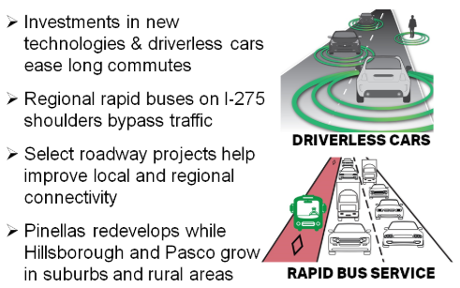

**Rapid Buses**

Survey commentators identified buses as an important component of Scenario A. In particular, rapid bus service was felt to be an important improvement, with dedicated lanes helping buses become a more attractive and competitive travel option. Yet, many commentators found fault with the existing bus service and extended this criticism to include a dislike for increasing bus service unless service, frequency of stops and other amenities were improved. Commentators were also somewhat skeptical and uncertain of autonomous vehicles, or any automated rapid transit system. In fact, some stated a strong dislike for this type of service.

**Personal / Autonomous Vehicles**

Survey commentators also commented on advanced technology as it related to personal vehicles. Overall, commentators appear to be uncertain of how effective autonomous vehicles could be in solving traffic issues in the region. A review of the comments suggests that the majority were largely negative and there were similar criticisms that were mentioned when discussing autonomous transit vehicles. It should be noted that some commentators expressed enthusiasm for autonomous cars, but some still reference this concept as “too Star Trekkie,” “robotic,” and have concerns about the overall safety of private autonomous vehicles.

**Dedicated / Express Lanes**

Survey commentators also commented on the concept of bus lanes, express lanes, and toll lanes. Opinions regarding bus lanes were generally split between positive and negative comments, but there was concern about dedicating an entire lane to buses. Survey commentators who talked about express lanes in general provided a lukewarm response, but this could be a result of commentators connecting express lanes with having to pay tolls. In general, dedicating a lane to any one purpose was viewed negatively by survey commentators, with some expressing concern that increasing the number of toll roads would negatively impact lower-income individuals.

**Rail Transportation**

While not specifically listed in the scenario description, the concept of rail transportation was mentioned very broadly. By far, the largest number of commentators commented on light rail as a possible option to enhance travel within the region (these comments expressed interest in rail but did not demonstrate direct support for light rail). Some commentators expressed support for a variety of rail solutions such as a monorail or trolleys. In general, survey commentators indicated a preference for rail over rapid bus service or other local bus improvements.

**Comprehensive System**

The concept of system elicited the more thoughtful comments, with people commenting on the need to develop a holistic system and wanting to avoid a piecemeal approach to implementing transportation and other infrastructure improvements. Some commentators discussed the concept of a metropolitan area and the need for coordinated regional transportation investments that would benefit everyone. Some referenced the buses and rail systems found in larger metropolitan areas such as New York, while others referenced international systems as good examples of providing a comprehensive multimodal transportation system.

**Toll Roads**

The concept of tolls, or toll roads, was roundly criticized. A larger majority of commentators did not like the idea of toll roads and indicated they would never use them if they were to be built. Of those supporting toll roads, several suggested the need to include variable pricing.

**Transit**

The concept of transit also generated many comments. Three themes emerged in the analysis of transit: 1) mass transit, 2) public transit, and 3) rapid transit (previously discussed). Generally, commentators were receptive to mass transit provided it was convenient, fast and efficient, but there were commentators who felt that mass transit was too expensive and not a viable option for the Tampa region. Public transit was mentioned as a possible solution, though one commentator felt it to be a “terribly antiquated” system. Commentators who discussed rapid transit felt a solution could consist of converting old railways or constructing other dedicated lines to serve that purpose. Among those who expressed a dislike for transit it was generally identified as too expensive. Others expressed concern regarding some recent trends that show declining ridership and some stated it would require constant policing.

**Scenario B Comments**

**Imagine a future where we primarily invest in EXPRESSWAY LANES forming an outer loop so traffic does not have to go through the congested center of the region.**

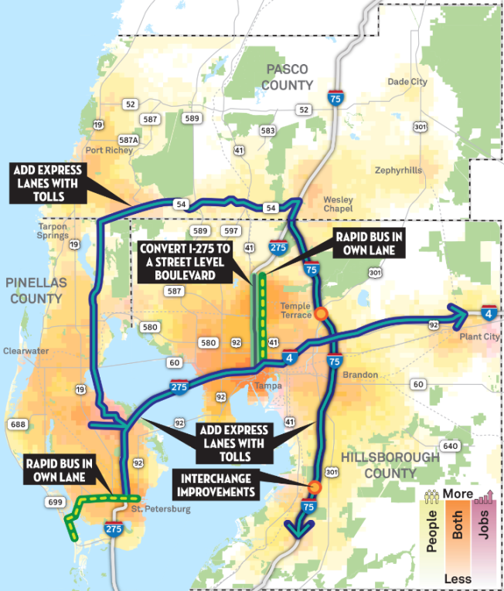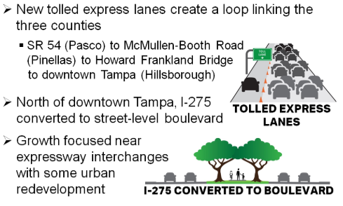

**I-275 Boulevard Conversion**

The boulevard concept (turning Interstate-275 into a Dale Mabry-type boulevard) was strongly criticized. While there was some support for it as an idea of “thinking outside the box,” insofar as it would provide more green space, many others denigrated it as being nonsensical, “pie in the sky,” or otherwise absurd.

**Expressway Connection**

The expressway concept was viewed with skepticism due to mostly to the lack of physical space to construct it and the aversion many people have for paying tolls. However, some commentators were open to the concept as long as construction would not negatively impact the communities where the expressways would be located.

**Tolled Express Lanes**

The concept of tolled express lanes concept was clearly categorized into two themes: 1) toll lanes and 2) express lanes. Overall, the comments to toll lanes were almost uniformly hostile. Several commentators noted tolls to be a way of penalizing the poor and creating an unequal transportation system. Express/Expressway lanes had a more mixed comments. Some commentators had positive comments as long as the express lanes incur no cost to drivers and help alleviate traffic congestion. Some comments that were against express lanes due to concerns about encouraging sprawl and being financially unfeasible.

**Roads / Traffic**

As this scenario focused mostly on roadway investments, survey commentators provided some general comments related to roads/traffic. Some commentators expressed displeasure about the condition of the current roads and the desire to maintain and repair the existing road network. As with comments provided in Scenario A, several commentators viewed traffic as “horrific” and continuing to worsen. As far as solving the problem of traffic, some embraced the idea of mass transit while others encouraged investment in pedestrian and bike infrastructure in support of developing alternatives to driving.

**Scenario C Comments**

**Imagine a future where we primarily invest in BUS AND RAIL SERVICES connecting, revitalizing and in-filling the communities that exist today.**

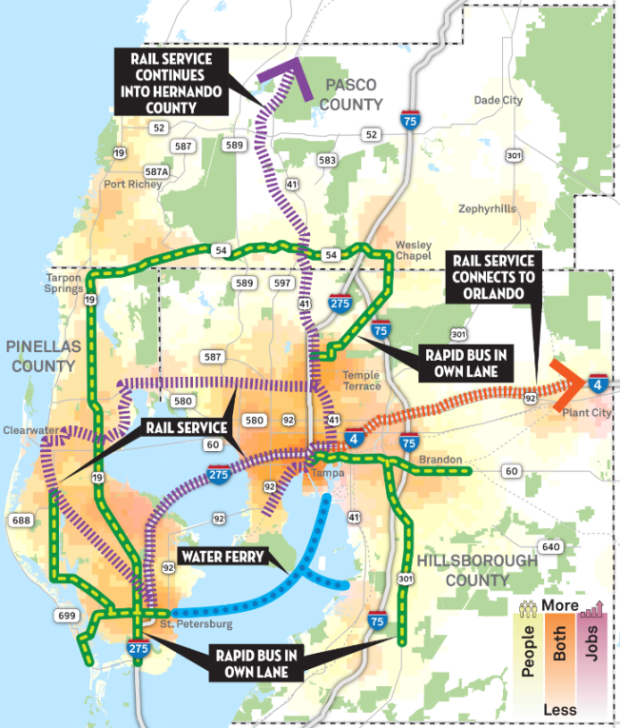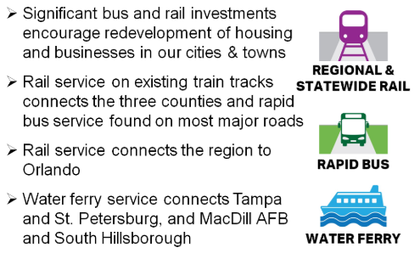

**Water Ferry**

The ferry concept received mostly positive comments. There were some concerns related to the feasibility and the cost of the project, but most viewed it as a good opportunity to connect the downtowns of Tampa and St. Petersburg. Some commented on this project as an example of finding creative transportation solutions to address regional needs. Some criticized it “transportainment” and not a real solution to the transportation needs.

**Rail**

A majority of survey commentators support investment in rail and several commentators were enthusiastically behind the implementation of rail service; however, some commentators clarified that their support was contingent on the rail projects being feasible and not costly. Others opined that rail service is “sorely needed” and needs to be “the number one priority.” While some commentators find consensus that rail would only solve part of the problem, most agree it is an option that should be pursued. By comparison, bus service received few comments and seemed to somewhat lack support. Several comments emphasized that the service needed to be accessible, reliable and serve the greatest number of people.

**Transit (General Comments)**

Some of the comments focused more broadly on transit, and transit usage. Generally speaking, most commentators have a favorable opinion and support for public transportation. Public transit was sometimes touched on cursorily as an “excellent investment” and “great idea,” provided that people use it. One commentator stated that “Floridians just don’t take public transit.” When discussing transit generally, commentators valued transit for its energy efficiency and looked at transit as an investment for future generations. Some commentators indicated that transit seems to be the most logical solution to address traffic issues in the tri-county area, under the assumption that we just can’t continue to build roads to accommodate the growth that is occurring within the region.

**Traffic**

Some survey commentators took the opportunity to comment generally about traffic within the region. Similar to Scenarios A and B, some commentators emphasized that traffic congestion is a problem that needs to be addressed. While in agreement on the problem, there are multiple options and solutions that people want to consider. It appears that some commentators are willing to pay more for alternatives that could potentially improve mobility within the region, while others indicated they are not willing to pay any additional fees or taxes for transportation investments.

With regard to traffic as a general concept, most commentators want less car traffic and more options and accessibility to alternative modes of transportation. Similar to comments associated with the previous scenarios, some commentators expressed concern regarding how transportation problems disproportionately affect the poor and indicated that public transportation could provide an equitable solution.

|  |
| --- |
| **Elements** |

Survey respondents were asked to consider the elements, or components, of the three scenarios to help better understand potential roadway projects, transit projects, community development, and funding options. The Elements were used to drill down into the ingredients that make up each of the scenarios in order to help inform what components should be included in a hybrid transportation and growth scenario. The following sections summarize the comments associated with each Element.

|  |  |
| --- | --- |
| **Elements Screen** | **“What to Do” Pop-up Box** |

**It’s TIME Tampa Bay Elements**

|  |  |
| --- | --- |
| **Roadways**   * Advanced Technology * New/Expanded Ramps * Elevated Toll Roads * Complete the Loop * I-275 Boulevard | **Community**   * Expanded Growth Area * Preserve Neighborhoods * More/Better Downtowns * Efficient Use of Land * Walk & Bike Focus |
| **Transit**   * Expanded Ridesharing * Express Bus Rapid Transit * Rail (Local/Regional) * Water Ferry * Statewide Rail | **Funding**   * New Lanes with Tolls * Taxes/Fees for Roads * Taxes/Fees for Buses * Taxes/Fees for Rail * Special District Fees |

**Roadways Element**

The roadway elements included advanced technology, new/expanded ramps, elevated toll roads, complete the loop, and I-275 boulevard. This analysis was completed using software that analyzes key words and themes and provides a high level indication of the general survey comments. It was also conducted by a general review of the comments to identify key themes/messages. A total of 1,681 roadway related comments were recorded.

The comments were entered into a word cloud to generate an overview of commentator’s priorities. The word size is proportionate to the number of times each word was identified.

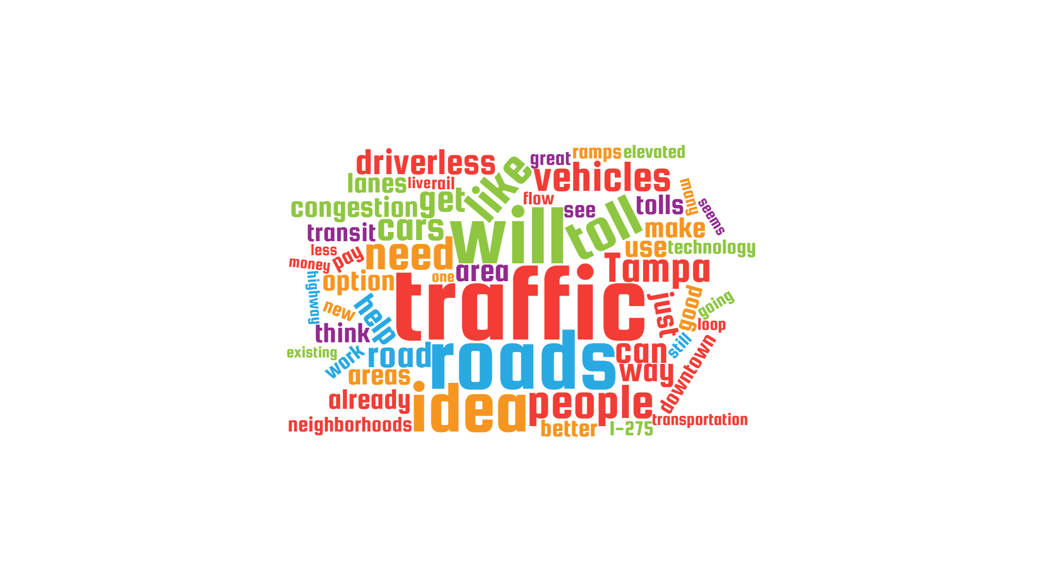 Source: Word Clouds.

**Comment Summary**

**Advanced Technology**

Generally, comments were positive toward the subject of advanced technology focusing primarily on managing traffic flow using smart technology and developing autonomous vehicles. Commentators mentioned concern over advanced technology and felt it was appropriate only when it is proven safe for use in the general public. Commentators generally support enhanced traffic signal technology and other solutions that will help reduce traffic congestion—especially during the morning and evening peak travel hours. Overall, survey commentators are somewhat uncertain regarding what types of technology improvements are available; however, commentators generally acknowledge that technology will be an important part of our future transportation system.

**New/Expanded Ramps**

New/expanded ramps were met with mostly positive comments. Review of the comments showed that any negativity within a comment was targeted mostly at high levels of traffic congestion throughout the region and not the concept of new and expanded ramps. Generally speaking, survey commentators seem to support targeted roadways improvements including new and expanded ramps as a solution for addressing congestion. However, there were a few commentators that do not want any additional roadway focused improvements and support investment in alternative travel modes.

**Elevated Toll Roads**

In general, survey commentators recognize the potential congestion relief that elevated toll roads could provide within the region. However, several comments were related to individuals not wanting to pay tolls. Many commentators said toll roads are not the answer to fund transportation improvements and had concerns that those who benefit the most are wealthy individuals. Some commentators were open to the idea of tolls as long as the fees were affordable.

**Complete the Loop**

There is some general consensus that the complete the loop concept helps provide a critical regional connection; however, there were numerous concerns regarding the cost associated with this project and the loss of open space resulting in mostly negative comments. Specifically, several commentators had concerns that this concept has the potential to encourage urban sprawl. A number of commentators were worried about the concept of the loop negatively impacting neighborhoods, and some questioned how a project could even be constructed in Pinellas County, where land to construct this facility is limited. For those who did support this concept, some felt from an equity standpoint that the roads should not be tolled.

**I-275 Boulevard**

Of the roadway elements, the I-275 Boulevard concept recorded a higher rate of less favorable comments. Some commentators acknowledged the concept of converting I-275 to a boulevard as forward-thinking, but many interpreted it as non-practical given the cost and concerns regarding surrounding roadways being able to accommodate the shift in traffic.

**Transit Element**

The transit elements included expanded ridesharing, express bus rapid transit, rail (local/regional), water ferry, and statewide rail. This analysis was completed using software that analyzes key words and themes and provides a high level indication of the general survey comments. It was also conducted by a general review of the comments to identify key themes/messages. A total of 1,619 comments were recorded.

The comments were entered into a word cloud to generate an overview of commentator’s priorities. The word size is proportionate to the number of times each word was identified.

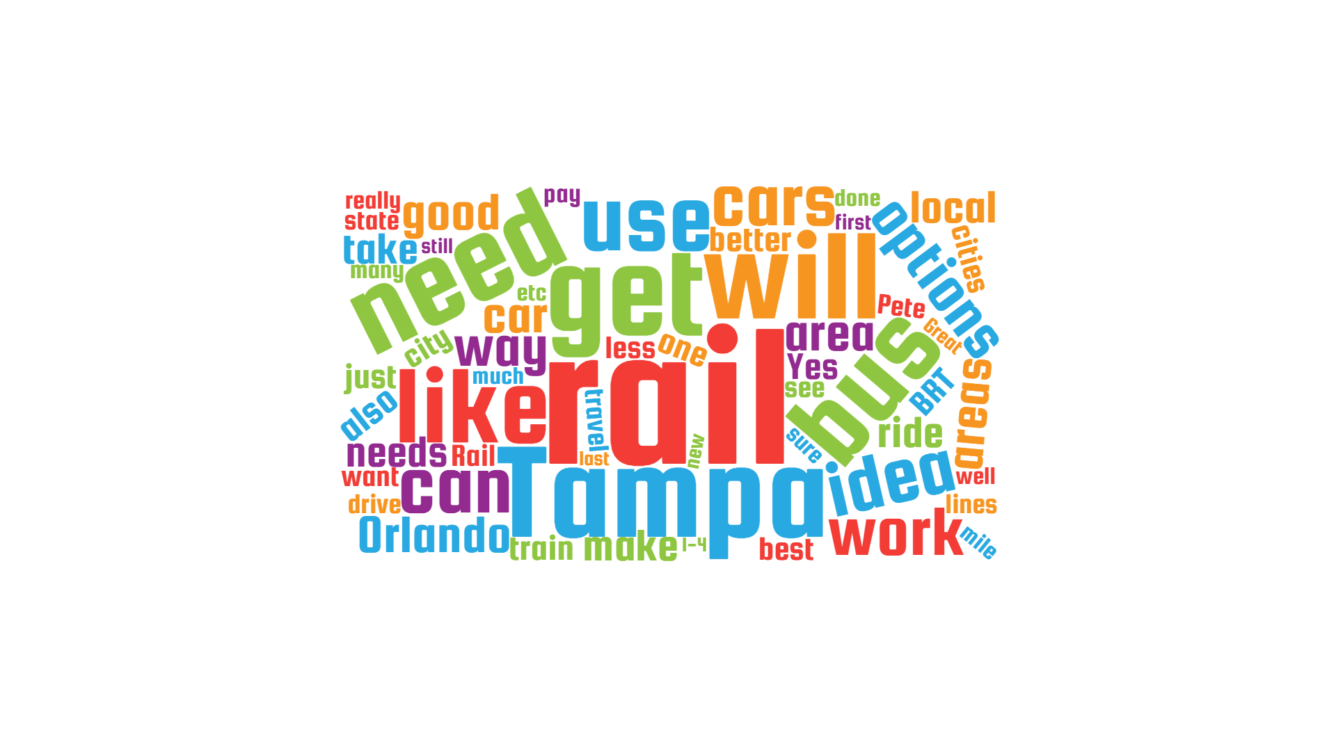Source: Word Clouds.

**Comment Summary**

**Expanding Ridesharing**

Those who had a negative opinion cited the added congestion due to the increase of rideshare vehicles on the roadways. Some were also concerned about transparency, as ridesharing companies are typically private and may not provide full details regarding their service to the general public. In general, some of these comments reflected commentators who were unfamiliar with how the service worked, or were uncomfortable using ridesharing services. On the other side, several commentators support ridesharing and see it as a way to increase mobility options, especially for those with limited access to other transportation alternatives.

**Express Bus Rapid Transit**

Despite commentators recognizing express bus rapid transit as an option to potentially decrease travel times, many survey takers did not want this element if it resulted in the reduction of a vehicular travel lane. Some commentators saw this as an inefficient method to decrease travel times because bus service frequency and ridership are too low to justify a dedicated lane. Several survey takers stated their preference for rail over express bus rapid transit. Others indicated that express bus service was a step in the right direction to expanding transit within the region.

**Rail (Local/Regional)**

Local and regional rail mostly received positive comments as many expressed their support saying that rail would provide a viable alternative to driving and could serve both urban and suburban areas through the Tampa Bay region. Some commentators saw rail as a viable option only if it is funded privately and without public funds. A few commentators mentioned locations in Europe and other U.S. metropolitan areas as examples of what rail service should look like, and to indicate how far behind they felt the Tampa region was regarding passenger rail service.

**Water Ferry**

Water ferries received a split decision as commentators believe ferries can be helpful in shuttling workers between destinations such as Tampa, St. Petersburg, and Bradenton while bypassing automobile congestion on area bridges; however, others don’t believe ferries will have a major impact on traffic relief. Some commentators indicated concerns about connections for ferry passengers at the docks. Specifically, some wondered if there would be access to bikes and other travel modes, especially for those using the ferry service to commute to work.

**Statewide Rail**

Statewide rail was met with predominantly positive comments as commentators frequently called out destinations such as Orlando, Miami, and Jacksonville as viable options to connect to the Tampa region. Some commentators indicated that a statewide rail system was more than just an important travel connection and that it would enhance economic development and support tourism throughout Florida. Despite predominantly positive comments, a few commentators were concerned about the cost and effectiveness associated with constructing and running a statewide rail system. Others questioned the ticket cost and whether a fare would be affordable to most people.

**Community Element**

The community elements included expanded growth area, preserve neighborhoods, more/better downtowns, efficient use of land, and walk & bike focus. This analysis was completed using software that analyzes key words and themes and provides a high level indication of the general survey comments. It was also conducted by a general review of the comments to identify key themes/messages. A total of 1,382 comments were recorded.

The comments were entered into a word cloud to generate an overview of commentator’s priorities. The word size is proportionate to the number of times each word was identified.

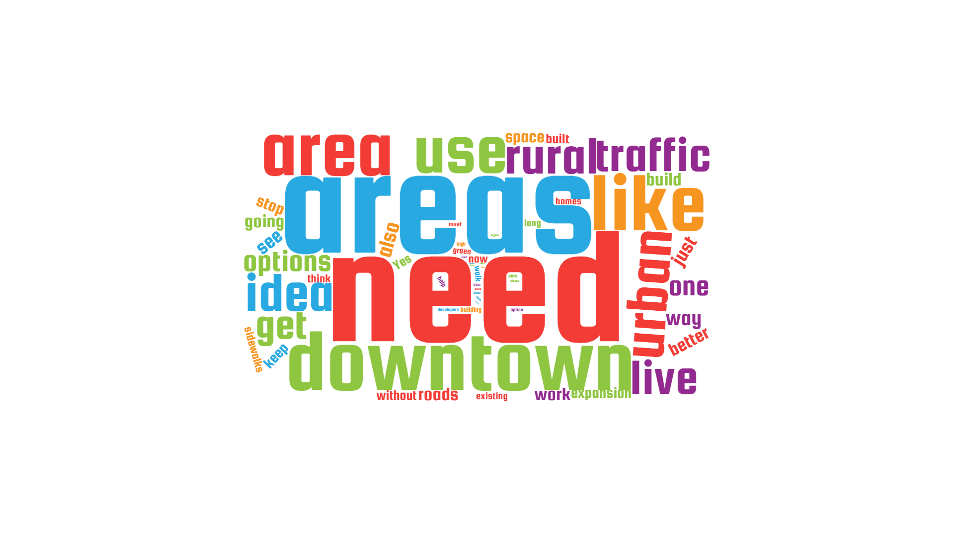 Source: Word Clouds.

**Comment Summary**

**Expanded Growth Area**

Commentators felt strongly that expanded growth areas are a major contributor to many of the transportation-related problems that currently impact the Tampa Bay region. Terms such as urban sprawl and loss of natural spaces were frequently mentioned as detrimental effects connected to expanded growth areas. Some commentators suggested that future growth should occur with higher density to reduce costs and be more efficient in providing infrastructure and other public services. Furthermore, some indicated that with increased density, alternative transportation modes—including transit, walking and biking—become more viable options to reduce roadway congestion.

**Preserve Neighborhoods**

People generally commented positively to preserving neighborhoods within the region. Some commentators mentioned preserving neighborhoods helps promote diversity, which can help enhance the sense of character and culture within an area. Another focal point among commentators is that focusing on revitalization of blighted areas and improving existing assets within neighborhoods can greatly improve communities.

**More/Better Downtowns**

Commentators pointed out how important a multimodal transportation network is to the health of downtown areas. Connecting neighborhoods via transit, walking, and bicycling offers residents alternatives to driving and can help reduce congestion. Many commentators acknowledged improvements in local downtowns across the region and mentioned the importance of expanding revitalization efforts by connecting mixed-use development with multimodal connections. Survey commentators cited affordability as key issue that should be considered, as many residents are priced out of housing developments in downtown areas.

**Efficient Use of Land**

Similar to other community element comments, commentators reiterated the importance of higher density and mixed-use development as the preferred use of land. Survey commentators focused comments on the protection of rural and natural areas by supporting the adoption of land use plans that encourage density and neighborhood diversity. Woven into land use planning should be a focus on multimodal infrastructure such as sidewalks and bike lanes that residents can benefit from.

**Walk & Bike Focus**

The walk & bike focus received favorable results with many commentators supporting action to improve walking and bicycling infrastructure. Many survey takers agreed that walking and bicycling provides a healthy and environmentally friendly alternative for residents. However, any improvement to the pedestrian and/or bikeway network must be made with safety as the top priority, as some cited close calls they’ve had with vehicles as they were bicycling or walking. The term ‘safe’ was mentioned 36 times among all comments within this element group, reinforcing this priority.

**Funding Element**

The funding elements included new lanes with tolls, taxes/fees for roads, taxes/fees for buses, taxes/fees for rail, and special district fees. This analysis was completed using software that analyzes key words and themes and provides a high level indication of the general survey comments. It was also conducted by a general review of the comments to identify key themes/messages. A total of 1,381 comments were recorded.

The comments were entered into a word cloud to generate an overview of commentator’s priorities. The word size is proportionate to the number of times each word was identified.

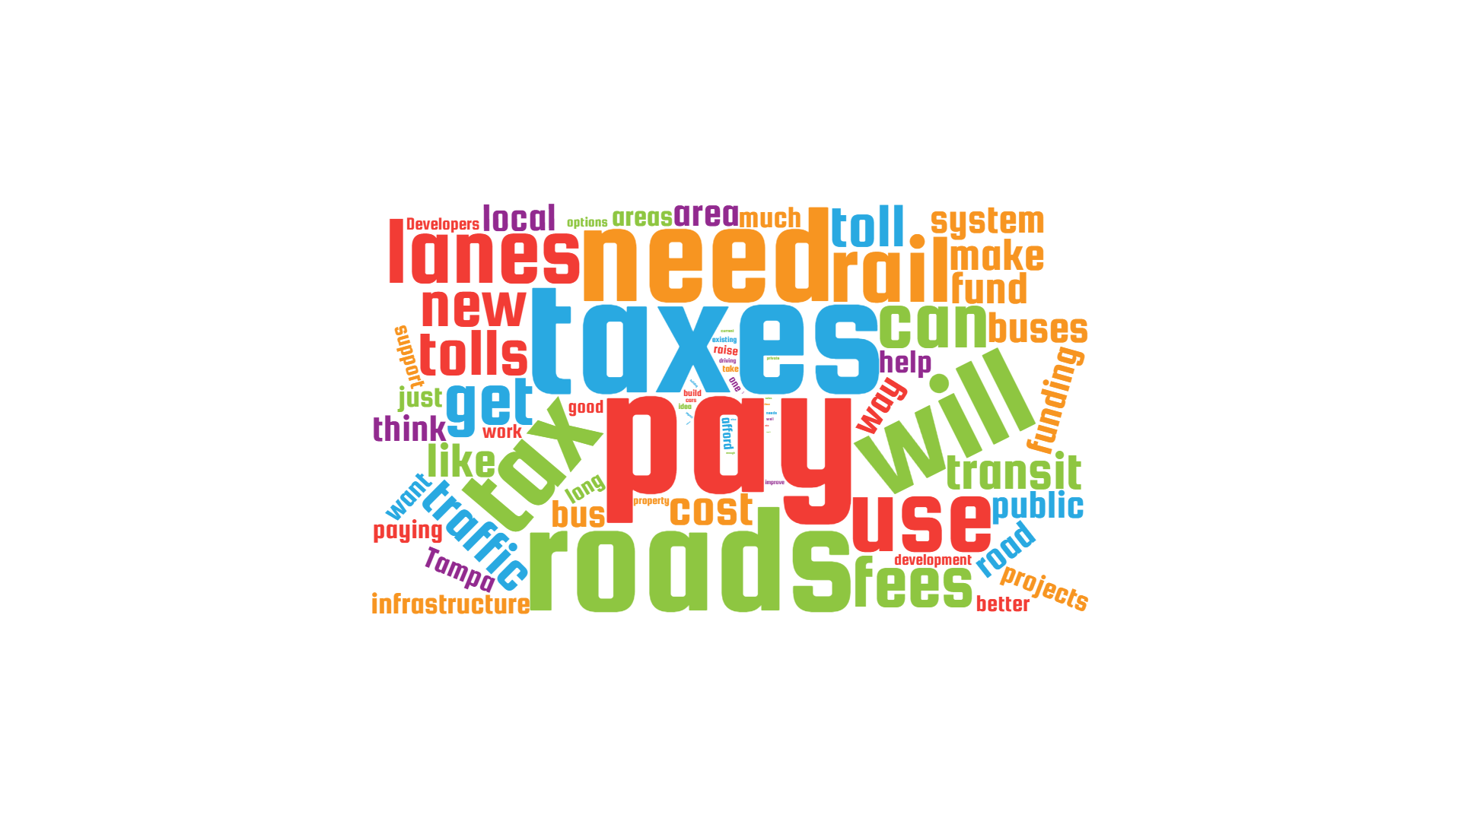 Source: Word Clouds.

**Comment Summary**

**New Lanes with Tolls**

Most survey commentators do not favor adding tolls. Some commentators were concerned that the cost to build new lanes is not fully covered by the tolls and others expressed concern that the construction of toll lanes would take away funds that could be used to improve existing roadways. Some suggested that private funding sources should be explored as an alternative to public funding, if added toll lanes are necessary. On the other hand, some commentators find new lanes with tolls acceptable as long as they are affordable and help relieve traffic congestion.

**Taxes/Fees for Roads**

Some commentators indicated that they would support increased taxes and fees for roads only when improvements are necessary. Others would support this concept if it helped reduce congestion; however, many survey commentators believe that adding roadway capacity only encourages people to drive and ultimately ends up adding congestion. Some commentators indicated a desire to use road taxes/fees to maintain and improve current roadways, while others suggested that roadway taxes/fees should also be used to invest in alternative transportation options, including carpooling programs.

**Taxes/Fees for Buses**

Survey takers expressed a desire to spend taxes/fees to best maintain and improve the effectiveness of the current bus system. Others felt that funding should focus on growing ridership on the existing system to increase user fees and decrease reliance on subsidies. Some indicated that using taxes/fees to expand express transit in suburban areas was an opportunity to enhance regional bus service.

**Taxes/Fees for Rail**

In comparison of other funding elements, rail taxes/fees received mostly favorable comments. Some commentators felt that funding rail is a good long-term opportunity that would complement other transportation modes in the Tampa region. Many commentators identified private investment as the preferred funding mechanism to minimize taxpayer burden. Those who expressed negative comments about rail taxes/fees noted the high infrastructure and user fee costs associated with building and operating the system.

**Special District Fees**

Special district fees received many negative comments among survey takers. Commentators indicated that special district fees must place fair responsibility on residents and businesses. Among commentators, developers were specifically called out 71 times within comments—primarily citing they need to pay their fair share toward infrastructure. Survey takers also commented that, when enacted, special district fees need to be transparent and clearly explained to residents. Overall, the high negative rating appears to be more associated with development concerns as opposed to a negative feeling toward this concept.